General
- MasterVision is updated every week with new and changed customer data (from Monday morning)
- 2.5 million unique individual records
- Currently, no concept of ‘best customer record’ but working on it
- Always click ‘Clear Search’ before you start

Default search exclusions
By default, search will exclude DECEASED, MEMBERS OF PUBLIC, VETS, UNSUBSCRIBES FROM EVERYTHING
Select your search parameters
- Profession (Doctor/Physician, Education, Nurse, Pharmacist, etc) – Individual Tab
- Country – Shared Tab
- Specialty Interest – Individual Tab
- Subscription Product or Event attended – Shared Tab (will be changing soon)
- Learning Channel (Individual Tab)
- Email Preferences (opt-ins) – “BMJ Group New Products and Services” and/or “BMJ Learning” – Individual Tab
- Unsubscribes – Everything (and BMJ Learning) – Individual Tab
- BenchPress journal – Individual Tab

Search Results and Exporting the data
- Click on any record in Search Results page to see summary page for that customer (eg jill.rasmussen@virgin.net)
- Click on “Export all search results” on search results page (see Figure 1 reverse)
- Select the fields for export (may just need customer number and email address unless you want to personalise the email) and then click on “Create and Download Export File” (see Figure 2 on reverse)
- If email address is missing from export, it is either going to be a hardbounced email address or a ‘unique’ BMA address

Managing unsubscribes
- Need a facility for people to ‘opt-out’ of receiving any similar emails
- Do you want to contact people asking them to ‘opt-in’ to your author/reviewer database? Or do you assume that they do until such a time as they ‘opt-out’ by unsubscribing?

Figure 1
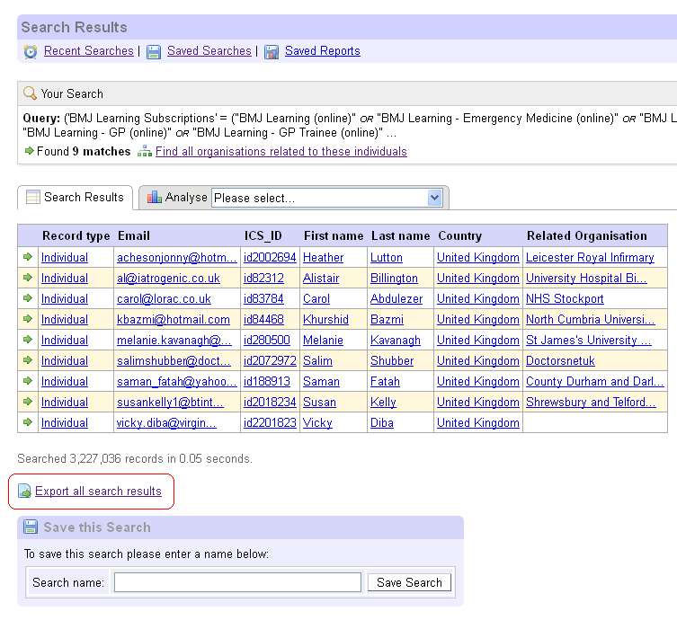
Figure 2
